Key Findings
- Youth mental health is worsening. 9.7% of youth in the U.S. have severe major depression, compared to 9.2% in last year’s dataset. This rate was highest among youth who identify as more than one race, at 12.4%.
- Even before COVID-19, the prevalence of mental illness among adults was increasing. In 2017-2018, 19% of adults experienced a mental illness, an increase of 1.5 million people over last year’s dataset.
- Suicidal ideation among adults is increasing. The percentage of adults in the U.S. who are experiencing serious thoughts of suicide increased 0.15% from 2016-2017 to 2017-2018 – an additional 460,000 people from last year’s dataset.
- There is still unmet need for mental health treatment among youth and adults. 60% of youth with major depression did not receive any mental health treatment in 2017-2018. Even in states with the greatest access, over 38% are not receiving the mental health services they need. Among youth with severe depression, only 27.3% received consistent treatment. 23.6% of adults with a mental illness reported an unmet need for treatment in 2017-2018. This number has not declined since 2011.
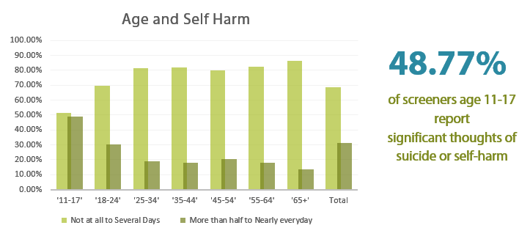

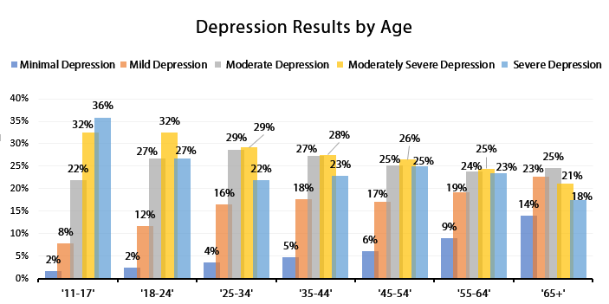

https://mhanational.org/issues/2020/mental-health-america-youth-data#one – interactive data source
This year’s report includes a spotlight on the impact of COVID-19 on mental health, using the over 1.5 million people who have taken a screen on MHA Screening from January to September 2020. SAMHSA, Center for Behavioral Health … calculated on 8/31/2016.

